May 15, 2012


Traffic.511.org
Add CMS Sign Content

Version 1.0

Prepared by:
SAIC
David Balmer


1000 Broadway, Suite 680
Oakland, CA 94612

Table of Contents

1 Overview 3
1.1 CMSUpdateService 3
1.2 CMSUpdateTester 3
2 Text Feed 3
3 Deployment 4
3.1 Database Scripts 4
3.2 Service Installation Scripts 4
3.2.1 Install.bat 4
3.2.2 Uninstall.bat 4
4 Configuration 5
4.1 Service Config file (used by the windows service) 5
4.2 Updater Config file (used by CMSUpdate, called by the windows service) 6
5 Testing and Debugging 7
5.1 CMSUpdateTester 7
5.2 CMSUpdateService 7
5.3 Fiddler 7
6 Sample HTML Report 8

Overview
This service updates the Changeable Message Signs (CMS Signs) displayed on the Traffic website.
SVN: http://vcs.lan.511.org/Repositories/TI_Prod/TI 511-Web/CMS Update
The solution consists of two projects:

CMSUpdateService
A windows service that requests a text feed from dot.ca.gov every 3 minutes to update the sign content. A status report is generated in xml format and transformed into html using an embedded xslt stylesheet. The service config file contains the feed url, the path to the TrafficCore config file, and the updater config file.
If any errors are encountered, the html report is sent as an attachment to a configurable mail account.

CMSUpdateTester
A console application that can test the update without installing the service.

Text Feed
http://www.dot.ca.gov/research/its/data/cms/cmsStatusD04.txt
The first line of the text file contains a timestamp value:
timestamp=10:30:10ÿ10/11/2012
Then each row is listed with ÿ as a column delimiter:
1ÿ4ÿCM001-MRN 101 N/B S/OF SIR FRANCIS DRAKEÿNorthÿMarinÿUS-101ÿÿÿ7.79ÿÿ-122.515881ÿ37.932114ÿ0ÿNOVATO 12 MINÿPETALUMA 24 MINÿSEARS PT 20 MINÿÿÿ
Which maps to our table structure:
0 |  | ID | 1
1 |  | ??? | 4
2 |  | Name | CM001-MRN 101 N/B S/OF SIR FRANCIS DRAKE
3 |  | Direction | North
4 |  | City | Marin
5 |  | RoadName | US-101
6 |  | ???
7 |  | ???
8 |  | ??? | 7.79
9 |  | ???
10 |  | Longitude | 122.515881
11 |  | Latitude | 37.932114
12 |  | ??? | 0
13 | &p1|1 | Line1 | NOVATO 12 MIN
14 | &p1|2 |  | PETALUMA 24 MIN
15 | &p1|3 |  | SEARS PT 20 MIN
16 | &p2|1 | Line2
17 | &p2|2
18 | &p2|3

Deployment

Database Scripts
The deployment folder contains a Deployment/dbscript.txt file with the required database updates.
- CREATE spUpdateCMSInfo
- CREATE spDeleteCMSInfo
- CREATE tblCMSInfo
- CREATE spGetCMSInfo
- CREATE spUpdateCMSInfo
- CREATE spDeleteCMSInfo

Service Installation Scripts
The deployment folder also contains batch files that support command line parameters.

Install.bat
@echo off
set SERVICE_NAME=CMSUpdateService
set SERVICE_EXE=CMSUpdateService.exe
set SERVICE_HOME=C:\Traffic\TI 511-Web\CMS Update\CMSUpdateService\bin\Release

REM The following directory is for .NET 4.0 on Windows XP
set INSTALL_UTIL_HOME=C:\WINDOWS\Microsoft.NET\Framework\v4.0.30319

REM Account credentials if the service uses a user account
REM set USER_NAME=<user account="">
REM set USER_PASSWORD=<user password="">

set PATH=%PATH%;%INSTALL_UTIL_HOME%

cd %SERVICE_HOME%

REM usage:
REM installutil /name=<service name=""> /account=<account type=""> /user=%USER_NAME% /password=%USER_PASSWORD% %SERVICE_EXE%

echo Installing Service...
installutil /name=%SERVICE_NAME% %SERVICE_EXE%
echo Done.

Uninstall.bat
@echo off
set SERVICE_NAME=CMSUpdateService
set SERVICE_EXE=CMSUpdateService.exe
set SERVICE_HOME=C:\Traffic\TI 511-Web\CMS Update\CMSUpdateService\bin\Release

REM The following directory is for .NET 4.0 on Windows XP
set INSTALL_UTIL_HOME=C:\WINDOWS\Microsoft.NET\Framework\v4.0.30319

set PATH=%PATH%;%INSTALL_UTIL_HOME%

cd %SERVICE_HOME%

echo Uninstalling Service...
installutil /u /name=%SERVICE_NAME% %SERVICE_EXE%
echo Done.

Configuration

Service Config file (used by the windows service)
CMSUpdateService.exe.config in the installation folder contains the following entries:
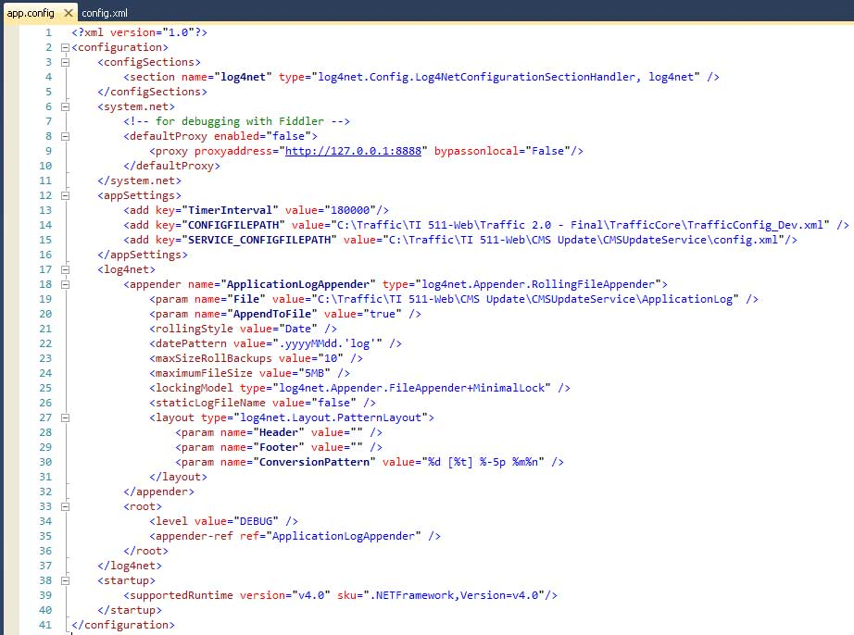

Updater Config file (used by CMSUpdate, called by the windows service)
The location of this file is defined in the SERVICE_CONFIGFILEPATH above.
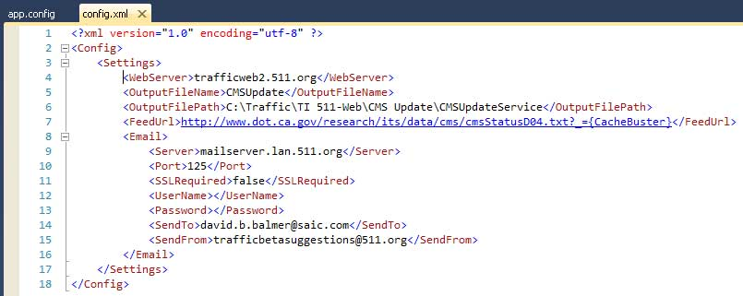

Testing and Debugging

CMSUpdateTester
Modify Program.cs to pass the location of the updater config file:
static void Main(string[] args)
{
using (CMSUpdater updater = new CMSUpdater())
{
updater.Init(@"C:\Traffic\TI 511-Web\CMS Update\CMSUpdateService\config.xml");
updater.Start();
};
}

CMSUpdateService
The easiest way I found to test the service, is to add a Debugger.Launch() call to Service.cs as below, which will be triggered when the service starts.
protected override void OnStart(string[] args)
{
TimerCallback callback = startCMSUpdater;

int timerInterval = int.Parse(ConfigurationManager.AppSettings["TimerInterval"]);

Debugger.Launch();

cmsUpdater = new CMSUpdater();
cmsUpdater.Init(ConfigurationManager.AppSettings["SERVICE_CONFIGFILEPATH"]);
timer = new Timer(callback, null, 1000, timerInterval);
}

Fiddler
Configure Fiddler to “Act as system proxy on startup” and set the proxyAddress in app.config:
<?xml version="1.0"?>
<configuration>
<configSections></configSections>
<system.net>
<defaultProxy enabled="true"><!-- for debugging with Fiddler -->
<proxy proxyaddress="http://127.0.0.1:8888" bypassonlocal="False"/>
</defaultProxy>
</system.net>
<appSettings></appSettings>
<log4net></log4net>
<startup></startup>
</configuration>

Reference:
- http://stackoverflow.com/questions/3444352/fiddler-not-displaying-sessions?rq=1
- http://stackoverflow.com/questions/2917732/is-there-a-way-to-configure-fiddler-to-intercept-http-calls-from-a-windows-servi

Sample HTML Report

